Section 4-1: Classifying Triangles

SOL: None

Objectives:
Identify and classify triangles by angles
Identify and classify triangles by sides

Vocabulary:
Scalene – no sides are congruent
Isosceles – two sides are congruent
Equilateral – all sides are congruent
Equiangular – all angles are congruent

Key Concepts:

Concept Summary:
Triangles can be classified by their angles as acute, obtuse or right
Triangles can be classified by their sides as scalene, isosceles or equilateral

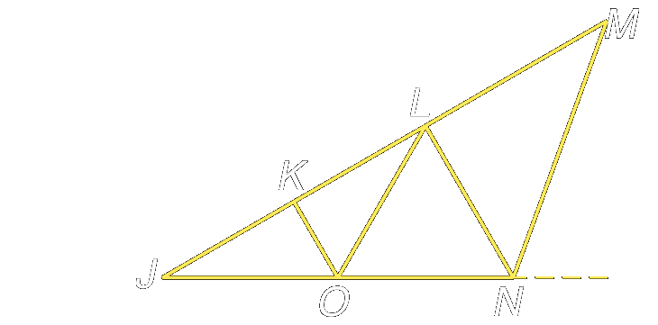
Example 1: The triangular truss below is modeled for steel construction. Classify ΔJMN, ΔJKO, and ΔOLN as acute, equiangular, obtuse, or right.

Example 2: The frame of this window design is made up of many triangles. Classify ΔABC, ΔACD, and ΔADE as acute, equiangular, obtuse, or right.

Example 3: Identify the indicated triangles in the figure.
a. isosceles triangles

b. scalene triangles

c. right triangle

d. obtuse triangle

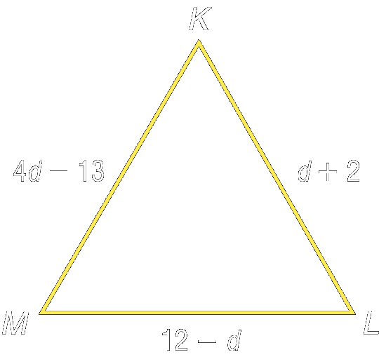
Example 4: Find d and the measure of each side of equilateral triangle KLM if KL = d + 2, LM = 12 – d and KM = 4d – 13.

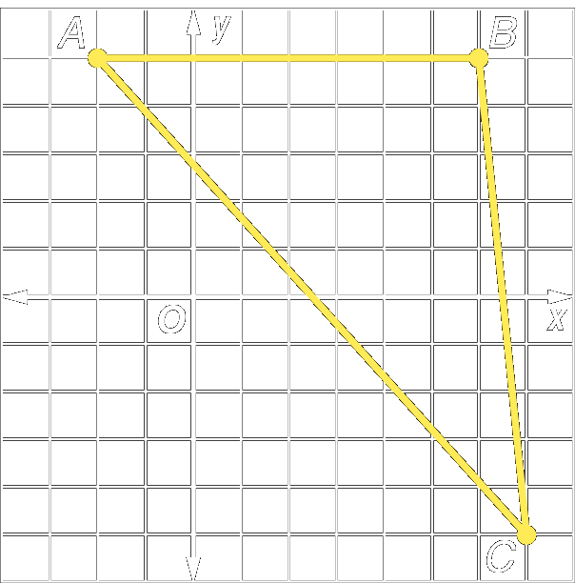
Example 5: Find the measures of the sides of ΔABC. Classify the triangle by sides

Reading Assignment: Section 4.2

Homework: pg 180-1: 5, 9, 13-18, 27
Section 4-2: Angles of Triangles

SOL: None

Objectives:
Apply the Angle Sum Theorem
Apply the Exterior Angle Theorem

Vocabulary:
Exterior Angle: is formed by one side of a triangle and the extension of another side
Remote Interior Angle: interior angles not adjacent to the given exterior angle
Corollary: a statement that can be easily proven using a particular theorem

Theorems:

Angle Sum Theorem: The sum of the measures of the angles of a triangle is 180°.

Third Angle Theorem: If two angles of one triangle are congruent to two angles of a second triangle, then the third angles of the triangles are congruent.

Exterior Angle Theorem: The measure of an exterior angle of a triangle is equal to the sum of the measures of the two remote interior angles.

Corollaries: 1) the acute angles of a right triangle are complementary
2) there can be at most one right or obtuse angle in a triangle

Concept Summary:
The sum of the measures of the angles of a triangle is 180
The measure of an exterior angle is equal to the sum of the measures of the two remote interior angles

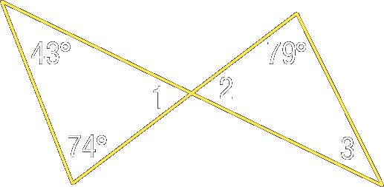
Example 1: Find the missing angle measures.

Example 2: Find the measure of each numbered angle in the figure.

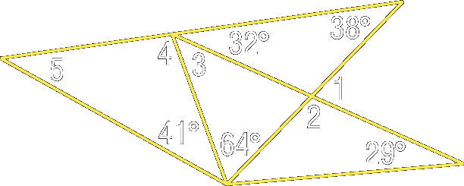
Example 3: Find the measure of each numbered angle in the figure.

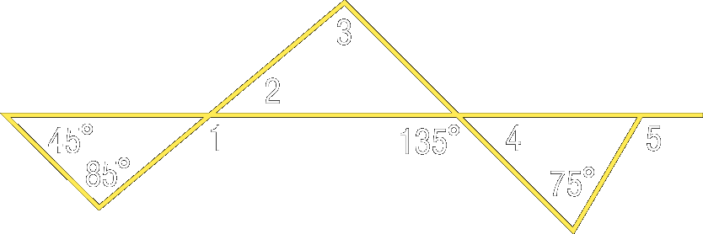

Example 4: Find the measure of each numbered angle in the figure.

Reading Assignment: Section 4.3

Homework: pg 188-9: 5-9, 18-23
Section 4-3: Congruent Triangles

SOL: G.5 The student will
a) investigate and identify congruence and similarity relationships between triangles;

Objectives:
Name and label corresponding parts of congruent triangles
Identify congruence transformations

Vocabulary:
Congruent triangles – have the same size and shape (corresponding angles and sides ≅)
Congruence Transformations:
Slide (also know as a translation)
Turn (also known as a rotation)
Flip (also known as a reflection)

Key Concepts:
Two triangles are congruent, if and only if, their corresponding parts are congruent
Order is important!!!

Theorems: Properties of triangle congruence:
Reflexive: ▲JKL ≅ ▲JKL
Symmetric: if ▲JKL ≅ ▲PQR, then ▲PQR ≅ ▲JKL
Transitive: if ▲JKL ≅ ▲PQR and ▲PQR ≅ ▲XYZ then ▲JKL ≅ ▲XYZ

Concept Summary:
Two triangles are congruent when all of their corresponding parts are congruent.

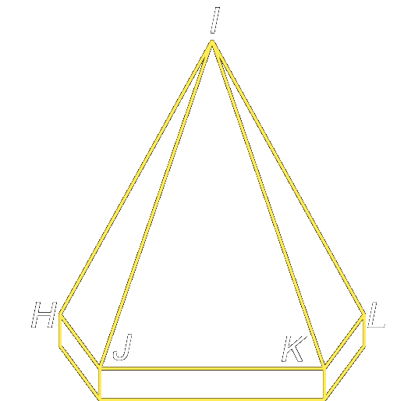
Example 1: A tower roof is composed of congruent triangles all converging
toward a point at the top.
- Name the corresponding congruent angles and sides of ΔHIJ and ΔLIK

- Name the congruent triangles

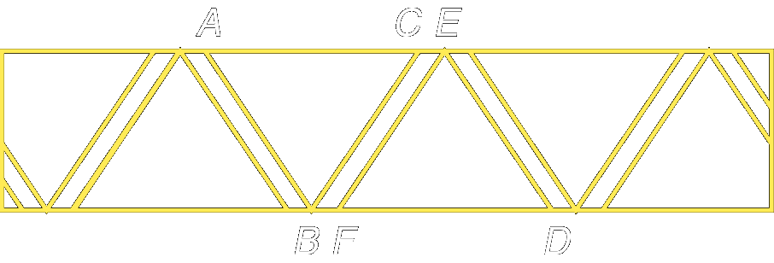
Example 2: The support beams on the fence form congruent triangles.

- Name the corresponding congruent angles and sides of ΔABC and ΔDEF.

- Name the congruent triangles.

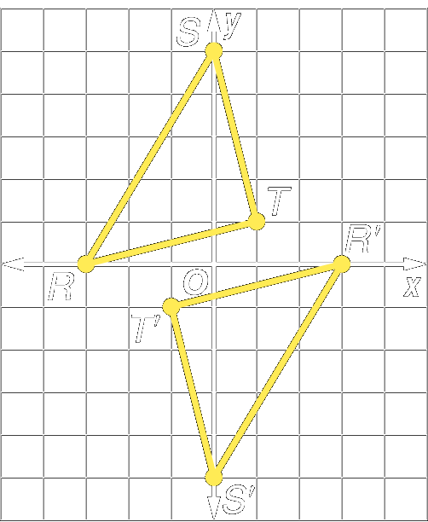
Example 3: The vertices of ΔRST are R(-3, 0), S(0, 5), and T(1, 1).
The vertices of ΔR′S′T ′ are R′(3, 0), S′(0, -5), and T′(-1, -1).
- Verify that ΔRST ≅ ΔR′S′T′.

- Name the congruence transformation for ΔRST and ΔR′S′T′.

Reading Assignment: Section 4.4

Homework: pg 195-198: 9-12, 22-25, 40-42
Section 4-4: Proving Congruence – SSS and SAS

SOL: G.5 The student will
b) prove two triangles are congruent or similar, given information in the form of a figure or statement, using algebraic and coordinate as well as deductive proofs.

Objectives:
Use the SSS Postulate to test for triangle congruence
Use the SAS Postulate to test for triangle congruence

Vocabulary:
Included angle: the angle formed by two sides sharing a common end point (or vertex)

Key Concepts:

Side-Side-Side (SSS) Postulate: If the sides of one triangle are congruent to the sides of a second triangle, then the triangles are congruent.

Side-Angle-Side (SAS) Postulate: If two sides and the included angle of one triangle are congruent to two sides and the included angle of a second triangle, then the triangles are congruent.

Concept Summary:
If all of the corresponding sides of two triangles are congruent, then the triangles are congruent (SSS).
If two corresponding sides of two triangles and the included angle are congruent, then the triangles are congruent (SAS).

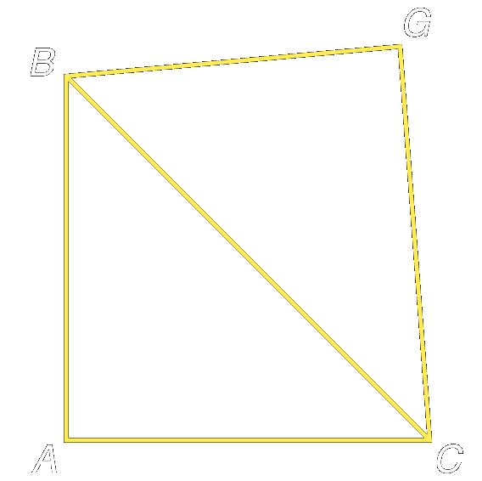
Example 1: Write a two-column proof to prove that ΔABC ΔGBC if GB ≅ AB and AC ≅ GC

Statement Reasons

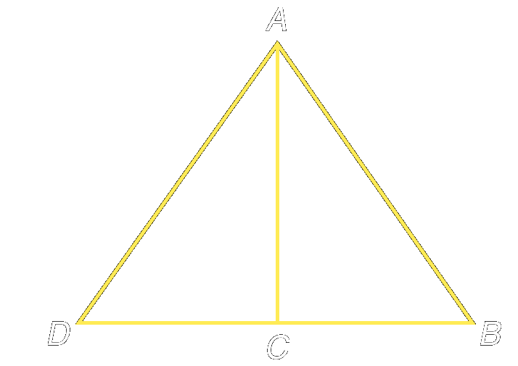
Example 2: Write a flow proof.

Given:C is midpoint of DB; ∠ACB ≅ ∠ACD

Prove: ∆ABC ≅ ∆ADC

Example 3: Determine which postulate can be used to prove that the triangles are congruent. If it is not possible to prove that they are congruent, write not possible
A. B.
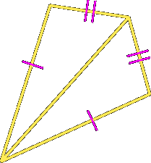
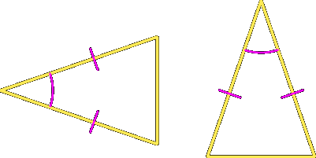

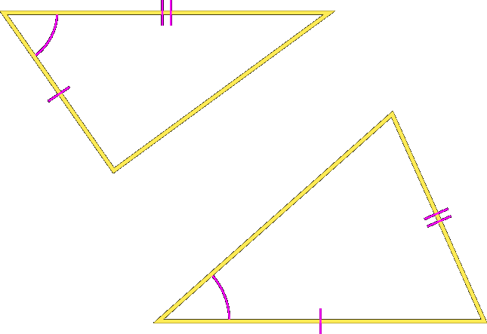
C. D.
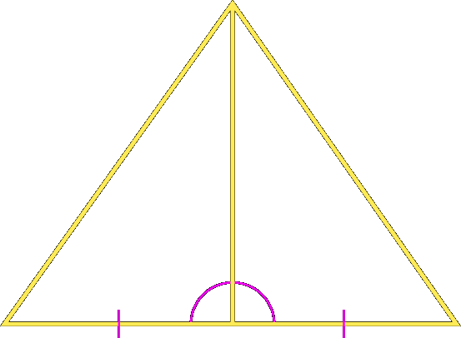

a. ______
b. ______
c. ______
d. ______

Reading Assignment: Section 4.5

Homework: pg 203 - 206: 6-8, 17, 22-25, 33-34
Section 4-5: Proving Congruence – ASA and AAS

SOL: G.5 The student will
b) prove two triangles are congruent or similar, given information in the form of a figure or statement, using algebraic and coordinate as well as deductive proofs.

Objectives:
Use the ASA Postulate to test for triangle congruence
Use the AAS Theorem to test for triangle congruence

Vocabulary:
Included side: the side in common between two angles (end points are the vertexes)

Key Concepts:

Angle-Side-Angle (ASA) Postulate: If two angles and the included side of one triangle are congruent to two angles and the included side of another triangle, then the triangles are congruent.

Angle-Angle-Side (AAS) Theorem: If two angles and a non-included side of one triangle are congruent to the corresponding two angles and side of another triangle, then the triangles are congruent.

Concept Summary:
If two pairs of corresponding angles and the included sides of two triangles are congruent, then the triangles are congruent (ASA).
If two pairs of corresponding angles and a pair of corresponding non-included sides of two triangles are congruent, then the triangles are congruent (AAS).
Section 4-4 & 5: Congruent Triangles

Concept Summary:

Known Parts | Definition | Able to determine congruency? | Reason
SSS | You know that all three sides of one triangle are equal to the corresponding three sides of another triangle | Yes | SSS postulate
SAS | You know that two sides and the angle between those two sides are equal to the corresponding two sides and included angle of another triangle | Yes | SAS postulate
ASA | You know that two angles and the side included between those two angles are equal to the corresponding two angles and included side of another triangle | Yes | ASA postulate
AAS | You know that two angles and one side not included between those angles are equal to the corresponding two angles and non-included side of another triangle | Yes | AAS Theorem (4.5)  Can get it into form of ASA, since other angle must also be congruent (sum of triangle’s angles = 180)
SAA | You know that one side and two angles which do not include that side are equal to the corresponding side and non-included angles of another triangle | Yes | Can get it into form of ASA, since other angle must also be congruent (sum of triangle’s angles = 180)
ASS | You know that one angle and two sides which do not include that angle are equal to the corresponding angle and two non-included sides of another triangle | No | Might be congruent, but cannot prove with given information
SSA | You know that two sides and a non-included angle are equal to the corresponding two sides and non-included angle of another triangle | No | Might be congruent, but cannot prove with given information
AAA | You know that all three angles of one triangle are equal to the corresponding three angles of another triangle | No | Sides are proportional (think concentric triangles)

Example 1: Write a paragraph proof

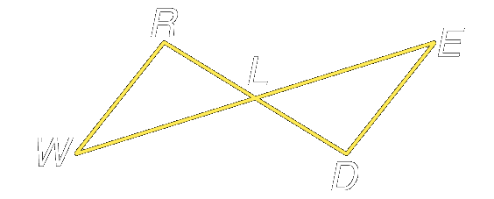
Given: L is the midpoint of WE and WR // ED

Prove: ∆WRL ≅ ∆EDL

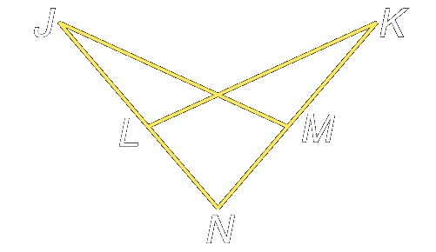
Example 2: Write a flow proof

Given: ∠NKL ≅ ∠NLM and KL≅JM

Prove: LN ≅ MN

Example 3: Write a flow proof.

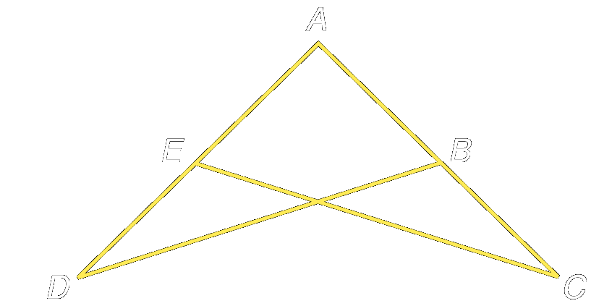
Given: ∠ADB ≅ ∠ACE and EC ≅ BD

Prove: ∠AEC ≅ ∠ABD

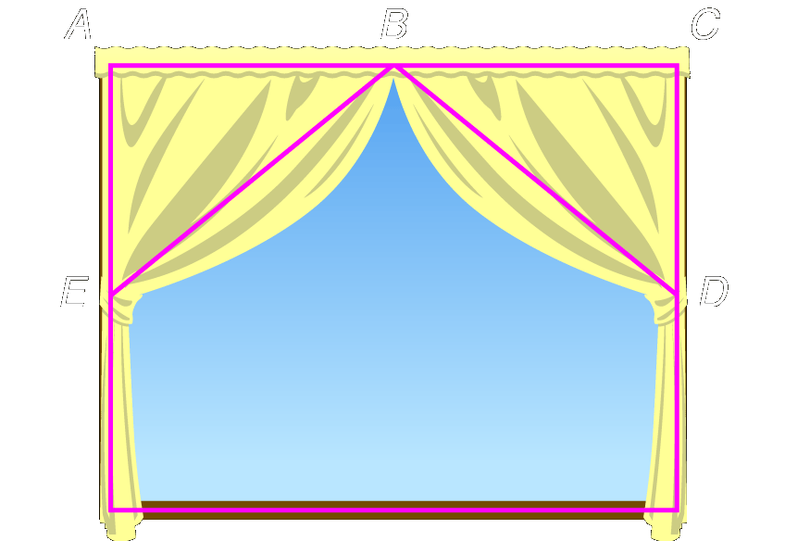
Example 4: The curtain decorating the window forms 2 triangles at the top. B is the midpoint of AC. AE = 13 inches and CD = 13 inches. BE and BD each uses the same amount of material, 17 inches. Determine whether ΔABE ≅ ΔCBD. Justify your answer.

Reading Assignment: Section 4.6

Homework: pg 211 - 212: 15-20 all in two-column proof format
Section 4-6: Isosceles Triangles

SOL: None.

Objectives:
Use properties of isosceles triangles
Use properties of equilateral triangles

Vocabulary:
Vertex angle – the angle formed by the two congruent sides
Base angle – the angle formed by the base and one of the congruent sides

Theorems:

Isosceles Triangle Theorem: If two sides of a triangle are congruent, then the angles opposite those sides are congruent.

Converse of Isosceles Triangle Theorem: If two angles of a triangle are congruent, then the sides opposite those angles are congruent.

Corollaries:

A triangle is equilateral if, and only if, it is equiangular.
Each angle of an equilateral triangle measures 60°.

Key Concepts:

Concept Summary:
Two sides of a triangle are congruent if, and only if, the angles opposite those sides are congruent.
A triangle is equilateral if, and only if, it is equiangular.

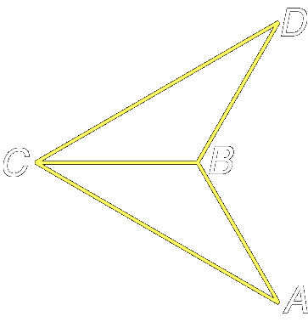
Example 1: Write a two-column proof

Given: AB = BC = BD ∠ACB ≅ ∠BCD

Prove: ∠A ≅ ∠D

Statement Reason

Example 2: If DE ≅ CD, BC ≅ AC and m∠DCE = 120°, what is the measure of ∠BAC?
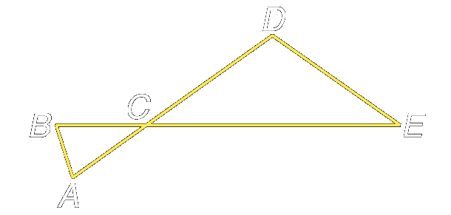
- 45.5
- 57.5
- 68.5
- 75

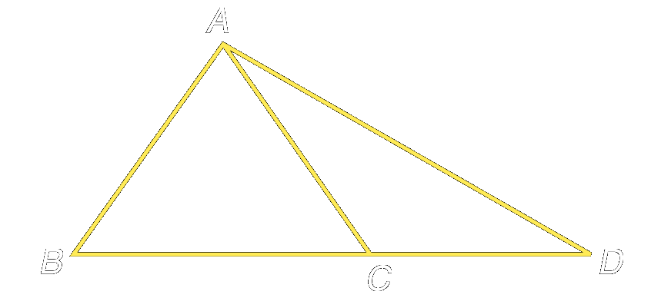
Example 3: If AB ≅ BC, AC ≅ CD, m∠ABC = 80°, what is the measure of ∠ADC?

- 25
- 35
- 50
- 130

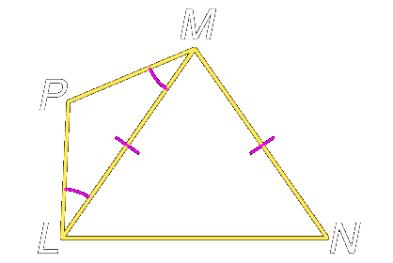

Example 4:
- Name two congruent angles

- Name two congruent segments

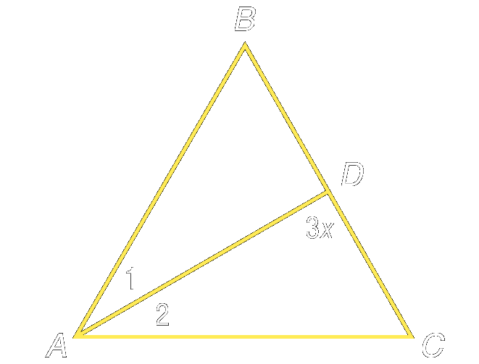

Example 5: ΔABC is an equilateral triangle. AD bisects ∠BAC

- Find x

- Find m∠ADB

Reading Assignment: Section 4.7

Homework: pg 219 - 20: 9, 10, 13-18, 27
Section 4-7: Triangles and Coordinate Proof

SOL: G.5 The student will
b) prove two triangles are congruent or similar, given information in the form of a figure or statement, using algebraic and coordinate as well as deductive proofs.

Objectives:
Position and label triangles for use in coordinate proofs
Write coordinate proofs

Vocabulary:
Coordinate Proof: Uses figures in the coordinate plane and algebra to prove geometric concepts.

Key Concepts:
- Use the origin as a vertex or center of the figure
- Place at least one side of a polygon on an axis
- Keep the figure within the first quadrant if possible
- Use coordinates that make computations as simple as possible

Concept Summary:
Coordinate proofs use algebra to prove geometric concepts.
The distance formula, slope formula, and midpoint formula are often used in coordinate proofs.

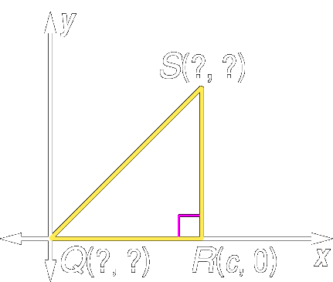
Example 1: Name the missing coordinates of isosceles right triangle QRS.

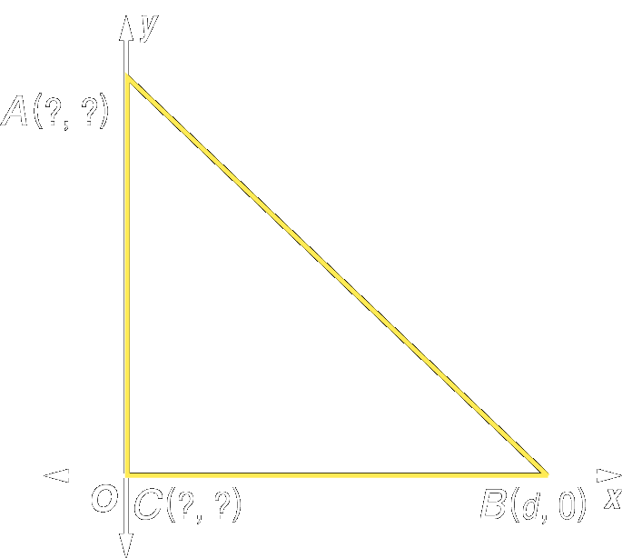
Example 2: Name the missing coordinates of isosceles right ΔABC

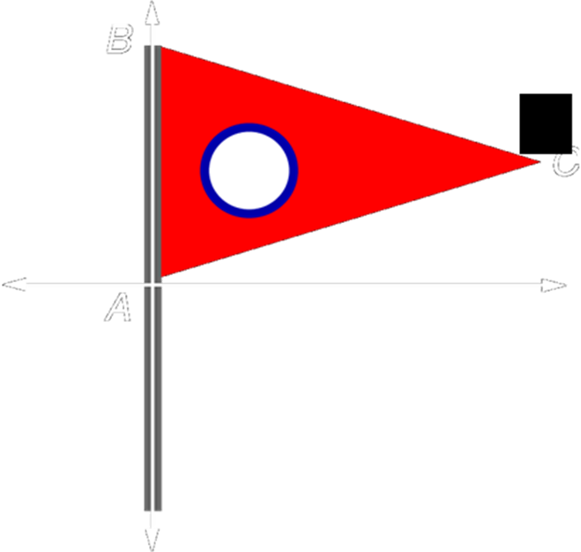
Example 3: Write a coordinate proof to prove this flag is shaped like an isosceles triangle. The length is 16 inches and the height is 10 inches

Reading Assignment: reread chapter 4

Homework: Chapter Review handout
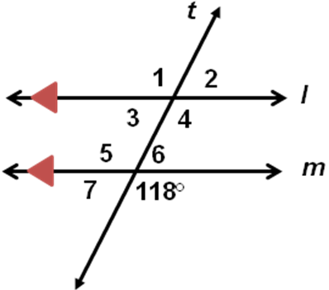
Lesson 4 -1: Refer to the figure.
1. What is the special name given to the pair of angles shown by ∠2 and ∠6?

2. Find m∠3.

3. Find m∠4.

4. Find the slope of the line that contains the points at (4, 4) and (2, –5).

5. Write the equation of a line in slope-intercept form that has a slope of ¾ and contains the point at (0, 5).

6. What is the slope of a line that is perpendicular to the line y = 2/3x – 5?
a. -3/2 b. -2/3 c. 2/3 d. 3/2

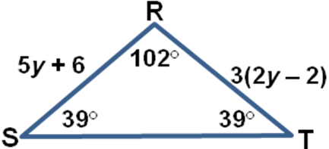
Lesson 4 -2: Refer to the figure.
1. Classify ΔRST as acute, equiangular, obtuse, or right.

2. Find y if ΔRST is an isosceles triangle with RS ≅ RT.

Refer to the figure.

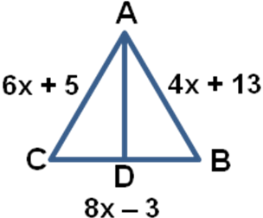
3. Find x if ΔABC is an equilateral triangle.

4. Name the right triangles if AD ⊥ CB.

5. Classify ΔMNO as scalene, isosceles, or equilateral if MN = 12, NO = 9, and MO = 15.

6. Choose the angle measures that represent the angles of an obtuse triangle.
a. 45,45,90 b. 60,60,60 c. 50,60,70 d. 30,50,100

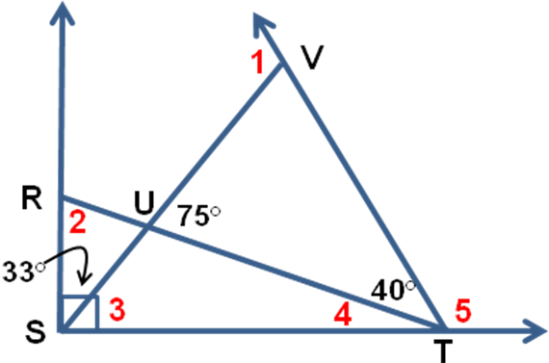
Lesson 4 -3: Find the measure of each angle.
1. m∠1

2. m∠2

3. m∠3

4. m∠4

5. m∠5

6. Two angles of a triangle measure 46° and 65°. What is the measure of the third angle?
a. 65° b. 69° c. 111° d. 115°

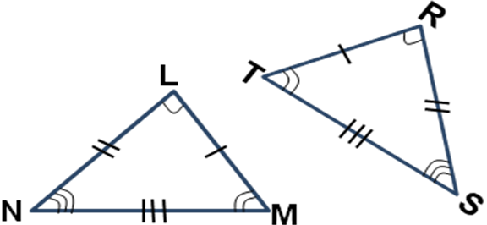
Lesson 4 -4 :Refer to the figure.
1. Identify the congruent triangles.

2. Name the corresponding congruent angles for the congruent triangles.

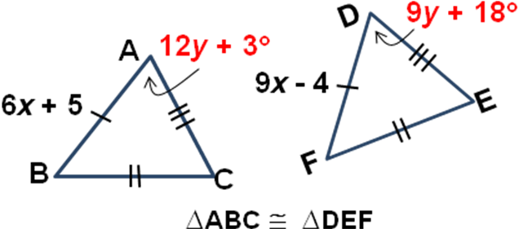
3. Name the corresponding congruent sides for the congruent triangles.

Refer to the figure.
4. Find x.

5. Find m∠A.

6. Find m∠P if ΔOPQ ≅ ΔWXY and m∠W = 80°, m∠X = 70°, m∠Y = 30°.
a. 30° b. 70° c. 80° d. 100°

Lesson 4 -5: Determine which postulate can be used to prove that the triangles are congruent. If it is not possible to prove they are congruent, write not possible.
1. 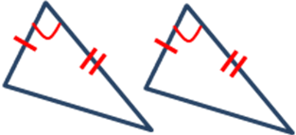 2. 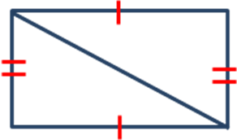 3. 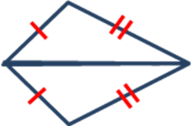
4. 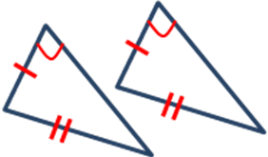 5. 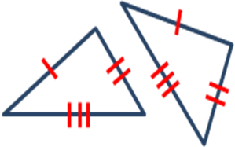
6. If AB ≅ RS and BC ≅ ST, what additional congruence statement would be necessary to prove ΔABC ≅ ΔRST by the SAS postulate?
a. ∠A ≅ ∠R b. ∠C ≅ ∠T c. ∠A ≅ ∠T d. ∠B ≅ ∠S
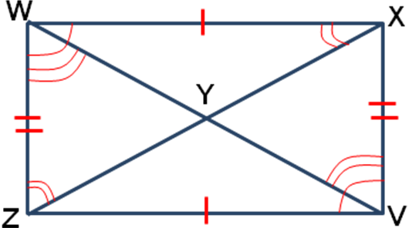

Lesson 4 -6: Refer to the figure. Complete each congruence statement and the postulate or theorem that applies.
1. ΔWXY ≅ Δ_____ by _____.

2. ΔWYZ ≅ Δ_____ by _____.
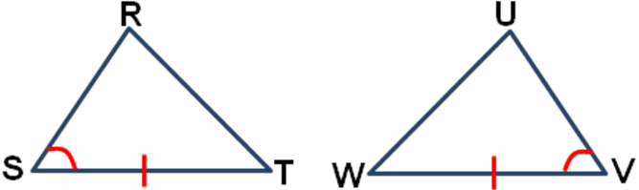
3. ΔVWZ ≅ Δ_____ by _____.

4. What additional congruence statement is necessary to prove
ΔRST ≅ ΔUVW by the ASA Postulate?
a. ∠T ≅ ∠W b. ∠R ≅ ∠U c. ST ≅ UW d. RT ≅ VW

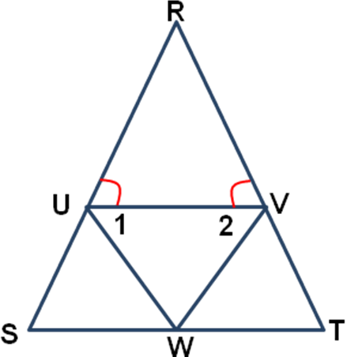
Lesson 4 -7: Refer to the figure.
1. Name two congruent segments if ∠1 ≅ ∠2.

2. Name two congruent angles if RS ≅ RT.

3. Find m∠R if m∠RUV = 65°.

4. Find m∠C if ΔABC is isosceles with AB ≅ AC and m∠A = 70°.

5. Find x if ΔLMN is equilateral with LM = 2x – 4, MN = x + 6, and LN = 3x – 14.

6. Find the measures of the base angles of an isosceles triangle if the measure of the vertex angle is 58°.
a. 38° b. 58° c. 61° d. 122°

